A community of around 1600 people live. They live on floating houses and re sustained through fishing and marine aquaculture.

Many of the islands have acquired their name as a result of tsunami

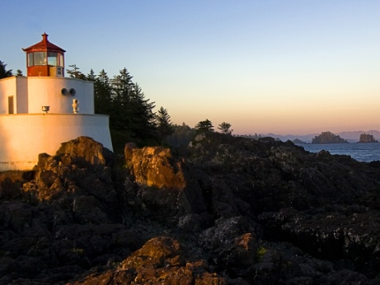

You are always a student, never a master. You have to keep moving forward –Conrad Hall

The only person who is educated is the one who has learned how to learn and change –Carl Rogers

Education is the best friend. An educated person is respected everywhere.

Education beats the beauty and the youth – Chanakya.

The foundation of every state is the Education of it’s youth – Diogenes.